Assignment (N+) Switching & VLANS
Task-1:
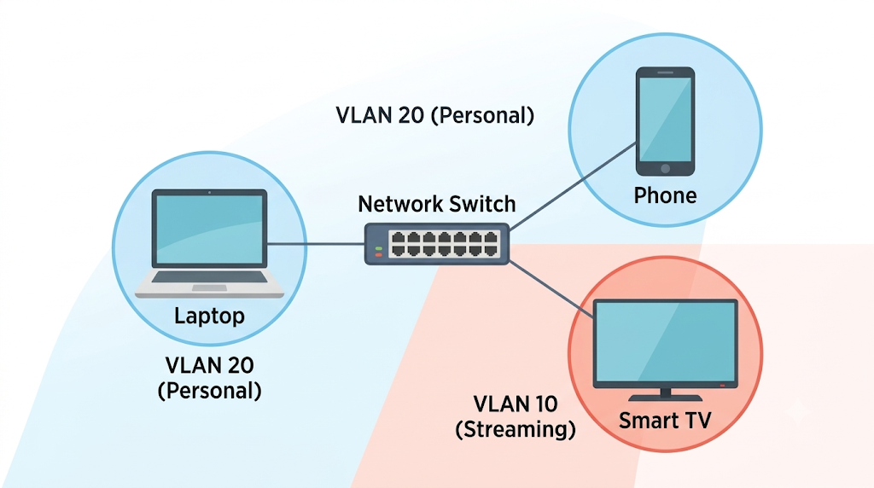

Task-2:
Click on this
Task-3:
Before Configuration (PC1 in VLAN 10)
Switch> enable
Switch# configure terminal
Switch(config)# interface FastEthernet0/1
Switch(config-if)# switchport mode access
Switch(config-if)# switchport access vlan 10
Switch(config-if)# end
After Configuration (Moving PC1 to VLAN 20)
Switch> enable
Switch# configure terminal
Switch(config)# interface FastEthernet0/1
Switch(config-if)# switchport access vlan 20
Switch(config-if)# end
Connectivity Test & Verification
- Run show vlan brief on the switch CLI to confirm FastEthernet0/1 is now explicitly listed under VLAN 20.
- Open the Command Prompt on PC1 in your simulator.
- Execute the ping command to PC2: ping 192.168.20.20.
- The output will show successful ICMP replies (Reply from 192.168.20.20: bytes=32 time<1ms TTL=128), confirming the port transition was successful and both devices share the same Layer 2 segment.

Task-4:
By utilizing the interface range command, you can apply the configuration to multiple ports at once without writing a script or repeating lines.
enable
configure terminal
vlan 30
name Delivery_Network
exit
interface range FastEthernet0/1 - 10
switchport mode access
switchport access vlan 30
end
write memory

